**Directions for Accessing eBooks Using Cobb Digital Library**

1. Go to the Cobb County district site at [www.cobbk12.org](http://www.cobbk12.org) and click Parents.

1. Click on Cobb Digital Library.

1. Click on the pinwheel icon.
2. Type the student’s Office 365 login, which is firstname.lastname* and use 123 for the password.

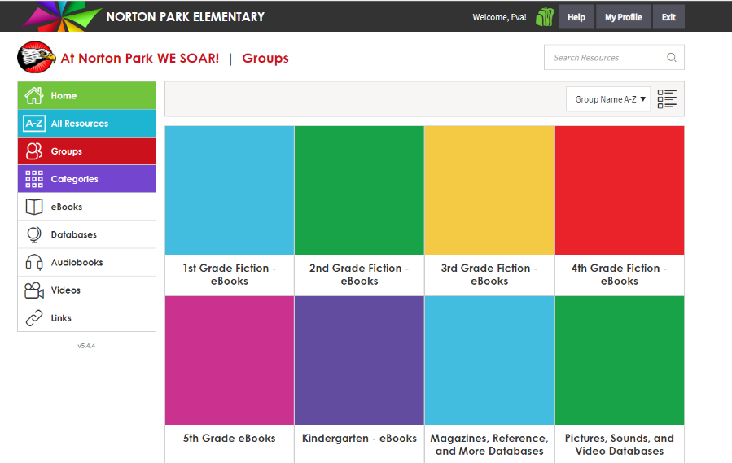

1. You will land on the Groups screen. There is a Group (or list) of ebooks for each grade level. Grades K through 4 lists are fiction only. The grade 5 list is a mixture of fiction and nonfiction. Click on the appropriate group for the student.



1. The majority of ebooks in the list are multi-user, which means multiple students can access them at the same time. Notice the book icons in the lower left corner. When you see one with a triangle (play symbol) in front of it, that book is a read-along, meaning the student can choose to have the book read to them as they read it.

1. Since each list has several hundred books in it, you can filter on different characteristics of the books in order to narrow down the list by using the options under “Advanced Search”. For example, if you click “Subject”, you can either scroll through the list of subjects (genres) or type in something you like to read about. Then you will only see books about that subject.

1. Some books will allow for users to check them out, but since publishers have made most books multi-user, checkout isn’t necessary to read the book. However, students may mark the book as a “favorite” or check it out if they’d like to find it again quickly. Move your mouse over the book image and click the heart icon to mark the book as a favorite. Click “Open Now” to begin reading the book.



1. To return to the entire list of books, click “Clear All Filters” under the “Advanced Search” heading on the left.



1. Click on the Backpack icon in the top right corner to view the students’ Favorites and current Checkouts.

1. To view all of the ebooks available for the school, click the eBooks button on the left. You may then use the Advanced Search filters to narrow down the list based on Reading Level, Subject, and any other criteria listed.



**Accessing Sora for eBooks via Cobb Digital Library**

**(Sora provides chapter books for 4th and 5th grade readers)**

1. To access Sora, click on the Databases button on the left side of the Cobb Digital Library home screen.

1. The **first time you access Sora**, you will see a window that asks “Is this your school?”. Click on “Norton Park”, if it appears on your list. If Norton Park isn’t listed, click “My school isn’t listed.”
2. Click on the Sora app to open. You may be prompted to enter your login credentials the first time you do this.

1. Type Norton Park in the search box. When the school name appears below the search box, click “This is my school”.

1. Click on “Sign in using Cobb County School District”.

1. Click on “Log in with Active Directory”. You will not be prompted to re-enter your credentials since they were entered previously.
2. Once you’ve opened Sora, you will be on the “Explore” page. Sora has a mixture of ebooks and audiobooks. Notice the headphones icon on some of the book titles. This tells you the book is in audiobook format. Unlike the Cobb Digital Library ebooks, Sora books must be checked out before they can be read, and there is a limit to how many users can check out the same book at one time. “Sora Sweet Reads” are books that can be checked out by unlimited users.

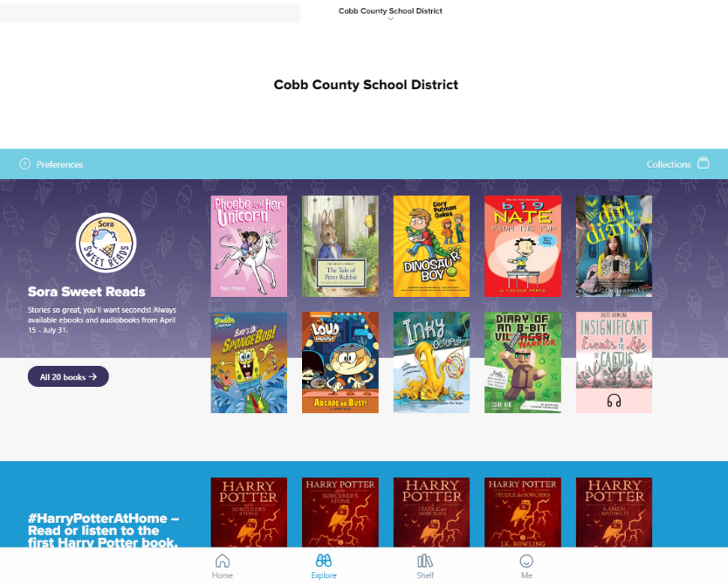

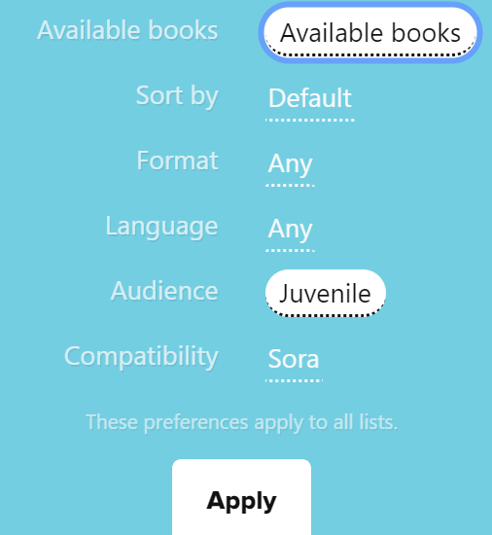

1. Use the “Preferences” feature to narrow down your list of books. Recommended preferences are: change “Available books” to “Available books” and “Audience” to “Juvenile”. Then click “Apply”.

1. To quickly locate a book with a genre/subject that you like, scroll down to the “Popular Subjects” section and click on one of the subjects.
2. Book icons will allow you to read a sample, place a hold, or borrow. Click on the book icon to see more information about it. **NOTE: If your Preferences are set to show only Available Books, you will only see “Borrow” next to the book icon.**

1. Click on the “Shelf” icon at the bottom of the screen to see the books you have checked out and to open and read your books. Once you’ve opened the book, click to advance the pages and click the “Close” button in the top left corner to close the book. Click “Options” to return the book.

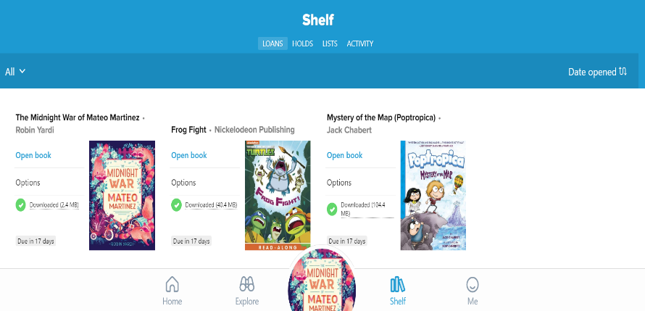

1. Sora also provides access to the Cobb County Public Library. To add that library to your list, click on the “hamburger” menu in the top right corner (three horizontal lines). Click “Add a public library” and then type Cobb County. Click “This is my library” to add it to your list of choices. Students can check out Cobb County Public Library books (either in person or online) by using their student/computer number and a four-digit PIN, which will be the month and day of their birth (two-digit day and two-digit month).

If you are using a smart phone or tablet to access ebooks, you can download both the MackinVIA (Cobb Digital Library) and Sora apps from the App Store or Google Play.

Sora

MackinVIA/Cobb Digital Library

*When entering the student’s Office 365 login, please remember that some double last names and more common names may be entered differently than you assume. If you have problems, please check with your child’s teacher for the exact name to enter.

If you have ANY problems logging in, please contact Ellen Adams, Norton Park media specialist, at [ellen.adams@cobbk12.org](mailto:ellen.adams@cobbk12.org)